Responsive Reading
591 Law and Gospel

Hymn: At the Cross p. 153
Was it for crimes that I have done
He groaned upon the tree?
Amazing pity! Grace unknown!
And love beyond degree!

The Collect
Gracious Father, whose blessed Son Jesus Christ came down from heaven to be the true bread which gives life to the world: Evermore give us this bread, that he may live in us, and we in him; who lives and reigns with you and the Holy Spirit, one God, now and forever. Amen.
Good people don’t go to heaven; Forgiven sinners do.

The Scriptures
OLD TESTAMENT
Numbers 21: 4-9 - 4 Then they [Israel] set out from Mount Hor by the way of the Red Sea, to go around the land of Edom; and the people became impatient because of the journey. 5 The people spoke against God and Moses, “Why have you brought us up out of Egypt to die in the wilderness? For there is no food and no water, and we loathe this miserable food.” 6 The LORD sent fiery serpents among the people and they bit the people, so that many people of Israel died. 7 So the people came to Moses and said, “We have sinned, because we have spoken against the LORD and you; intercede with the LORD, that He may remove the serpents from us.” And Moses interceded for the people. 8 Then the LORD said to Moses, “Make a fiery serpent, and set it on a standard; and it shall come about, that everyone who is bitten, when he looks at it, he will live.” 9 And Moses made a bronze serpent and set it on the standard; and it came about, that if a serpent bit any man, when he looked to the bronze serpent, he lived.
NEW TESTAMENT - GOSPEL
John 3:14-21 – [Jesus speaking] 14 “As Moses lifted up the serpent in the wilderness, even so must the Son of Man be lifted up; 15so that whoever believes will in Him have eternal life.

Fiery Serpent and Sin | Satan (original serpent) and Sin
Lack of faith or trust (or doubt) in God (His word and His promises) led to impatience and sin (speaking against God) | Lack of faith or trust (or doubt) in God (His word and His promises) led to being deceived and sin (acting against God)
God sent the fiery serpents | God allowed the serpent in the Garden
Israel wanted the serpents (their judgement and punishment) removed | We want our judgement and punishment removed
Punishment for sin was a bite of the serpent and death | Punishment for following the serpent and sin is death
Moses interceded for the people | Jesus intercedes for us
God provided one way of escape | God provides one way of escape
All who looked (and had faith) at the standard lived | All who look to Jesus on the cross and have faith will live
God provided a way of deliverance but still gave Israel free will | God provided a way of deliverance but still gives us free will

Advanced Bible Trivia Question:
Some six hundred years after Moses, which faithful and obedient king of Judea broke in pieces the bronze serpent because the sons of Israel had been burning incense to it and calling it Nehushtan? (2 Kings 18:4)
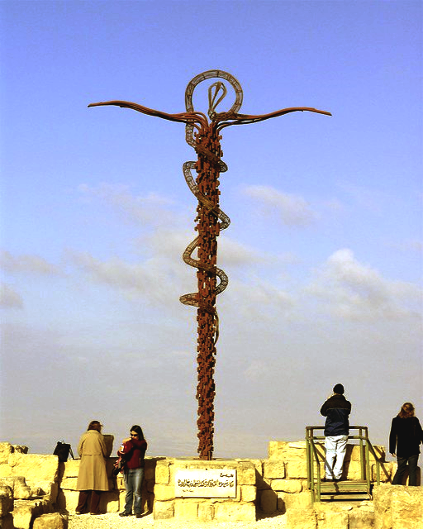
A modern monument of the bronze serpent (which Moses erected in the Negev desert) on Mount Nebo, in front of the church of Saint Moses (2018).
John 3: 16-21 - 16 “For God so loved the world, that He gave His only begotten Son, that whoever believes in Him shall not perish, but have eternal life. 17 “For God did not send the Son into the world to judge the world, but that the world might be saved through Him.

Jesus (the God Man; Emanuel) was sent for SALVATION, NOT condemnation or judgement.

18 “He who believes in Him is not judged; he who does not believe has been judged already, because he has not believed in the name of the only begotten Son of God. 19 “This is the judgment, that the Light has come into the world, and men loved the darkness rather than the Light, for their deeds were evil. 20 “For everyone who does evil hates the Light, and does not come to the Light for fear that his deeds will be exposed. 21 “But he who practices the truth comes to the Light, so that his deeds may be manifested as having been wrought in God.” Sermon May 5

NEW TESTMENT - EPISTLE
Ephesians 2:1-10 - 1 And you were dead in your trespasses and sins, 2 in which you formerly walked according to the course of this world, according to the prince of the power of the air, of the spirit that is now working in the sons of disobedience.
1 John 2:15-17 - 15 Do not love the world nor the things in the world. If anyone loves the world, the love of the Father is not in him. 16 For all that is in the world, the lust of the flesh and the lust of the eyes and the boastful pride of life, is not from the Father, but is from the world. 17 The world is passing away and also its lusts; but the one who does the will of God continues to live forever.
What is so bad about the world?
Revelation 12:9,10a,12: 9 And the great dragon was thrown down, the serpent of old who is called the devil and Satan, who deceives the whole world; he was thrown down to the earth, and his angels were thrown down with him. 10 Then I heard a loud voice in heaven, saying,….. 12 For this reason, rejoice, you heavens and you who dwell in them. Woe to the earth and the sea, because the devil has come down to you with great wrath, knowing that he has only a short time.”
1 John 5:19 - 19 We know that we are of God, and that the whole world lies in the power of the evil one.

3 Among them [unbelievers] we too all formerly lived in the lusts of our flesh, indulging the desires of the flesh and of the mind, and were by nature children of wrath, even as the rest.
Romans 3:23 - for all have sinned and fall short of the glory of God.
Ezekiel 18:4 - Behold, every soul belongs to Me; both father and son are Mine. The soul who sins is the one who will die.
Romans 6:23 - For the wages of sin is death, but the free gift of God is eternal life in Christ Jesus our Lord.
4 But God, being rich in mercy, because of His great love with which He loved us, 5 even when we were [spiritually] dead in our transgressions, made us alive together with Christ (by grace you have been saved), 6 and raised us up with Him, and seated us with Him in the heavenly places in Christ Jesus, 7 so that in the ages to come He might show the surpassing riches of His grace in kindness toward us in Christ Jesus.

We have the righteousness of Jesus. It was “imputed” to us. Like putting “on” Jesus (think of putting on Jesus’ garments as if from the Transfiguration. Justification = just as if we had no sin

2 Corinthians 5:21 – He [God] made Him [Jesus] who knew no sin to be sin on our behalf, that WE might become the righteousness of God in Him.
Romans 3:22a – even the righteousness of God through faith in Jesus Christ for ALL those who believe.
Hell was not created for mankind.
Matthew 25:41 – [Jesus speaking] Then He will also say to those on His left, ‘Depart from Me, accursed ones, into the eternal fire which has been prepared for the devil and his angels.
2 Peter 3:9 - The Lord is not slow about His promise, as some count slowness, but is patient toward you, not wishing for any to perish but for all [the world] to come to repentance.

8 For by grace you have been saved through faith; and that not of yourselves, it is the gift of God; 9 not as a result of works, so that no one may boast.
Good people don’t go to heaven, Forgiven Sinners do.
Luther – “Then I grasped that the justice of God is that righteousness by which, through grace and sheer mercy, God justifies us through faith.” (this is what makes us protestant)
Galatians 2:16 - nevertheless knowing that a man is not justified by the works of the Law but through faith in Christ Jesus, even we have believed in Christ Jesus, that we may be justified by faith in Christ, and not by the works of the Law; since by the works of the Law shall no flesh be justified.
Titus 3:4-7 – 4 But when the kindness of God our Savior and His love for mankind appeared, 5 He saved us, NOT on the basis of deeds which we have done in righteousness, but according to His mercy, by the washing of regeneration and renewing by the Holy Spirit, 6 whom He poured out upon us richly through Jesus Christ our Savior, 7 so that being justified by His grace we would be made heirs according to the hope of eternal life.

God does it all in terms of salvation, our part is only to believe (aka have faith) in His Son. We do not have the ability to even participate in our Salvation through our “righteous” deeds.
Isaiah 64:6 - For all of us have become like one who is unclean, and all our righteous deeds are like a filthy garment; And all of us wither like a leaf, and our iniquities, like the wind, take us away.

But Jesus’ righteous deeds are like a pure, white, shining, perfect garment that we put on (imputed).

Romans 3:10 - as it is written, “THERE IS NONE RIGHTEOUS, NOT EVEN ONE.
WHY?
Isaiah 55:8-9 - 8 “For My thoughts are not your thoughts, nor are your ways My ways,” declares the LORD. 9 “For as the heavens are higher than the earth, so are My ways higher than your ways and My thoughts than your thoughts. (two examples: going to space, and a mathematical graph)
John 14:6 - Jesus said to him, “I am the way, and the truth, and the life; no one comes to the Father, but through Me.”
10 For we are His workmanship, created in Christ Jesus for good works, which God prepared beforehand so that we would walk in them. Sermon May 5
You are NOT saved by your deeds. You are NOT saved by baptism. You are NOT saved by communion/Lord’s Supper. You are NOT saved by tithing. You are NOT saved by attending or being a member of a church. You are saved by the blood of Jesus!
Hymn: Turn Your Eyes Upon Jesus p. 87
His word shall not fail you he promised; Believe him and all will be well
Then go to a world that is dying; His perfect salvation to tell

If you don’t believe me, listen to what Billy has to say:
https://youtube.com/shorts/BC7SkB1NMro?si=wWVnRxyLH_QIPWbp

